Number zero or not

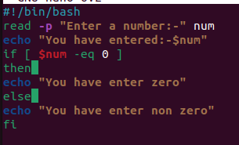

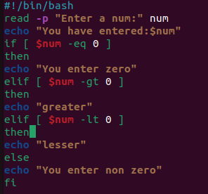

Greatest among 3 numbers

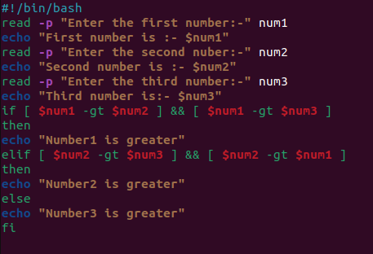

Calculator

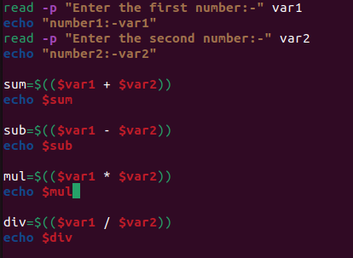

Printing 1 to 10 using for loop

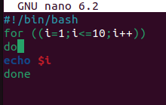

Printing 1 to 10 using until

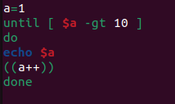

Sum of digits

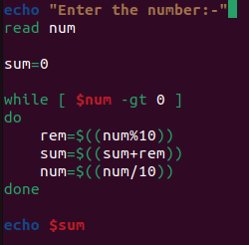

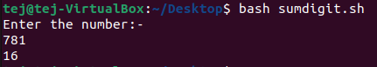

Odd numbers from 1 to 99

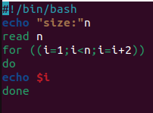

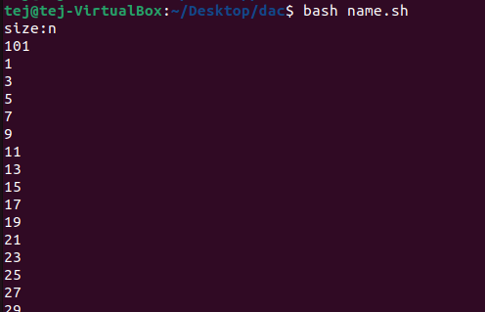

If y then print “YES” if n print “NO”

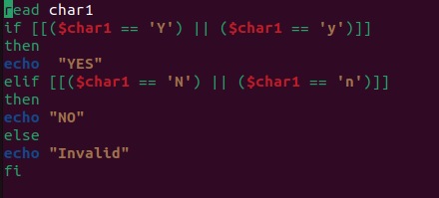

Given three integers (X,Y and Z ) representing the three sides of a triangle, identify whether the triangle is scalene, isosceles, or equilateral.

* If all three sides are equal, output EQUILATERAL.
* Otherwise, if any two sides are equal, output ISOSCELES.
* Otherwise, output SCALENE.

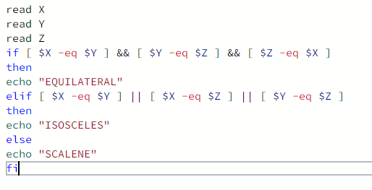

Swapping of 2 numbers

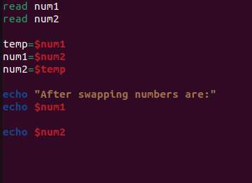

Even or odd

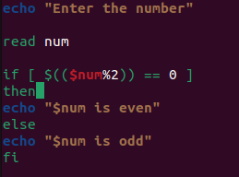

Divisible by 5 and 7

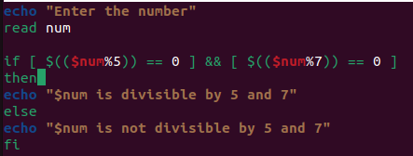

Triangle validity

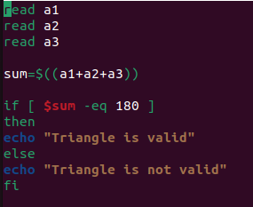

Patterns

1)

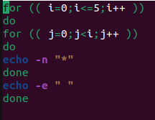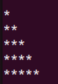

2)

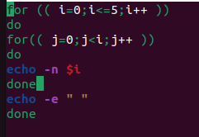 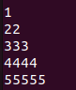

3)

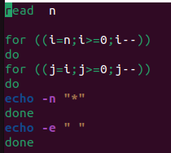 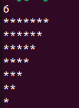

4)

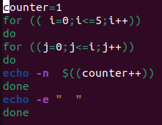 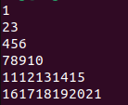

5)

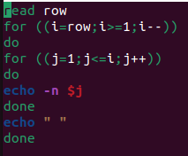 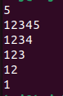

Sum of n numbers

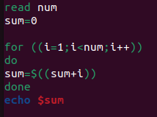

Reversing the number

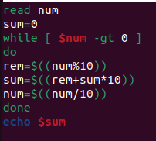

Palindrome

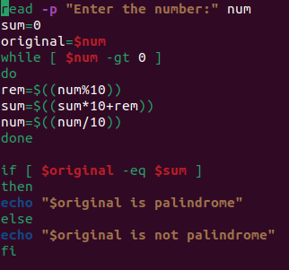

Pyramid and diamond

#!/bin/bash

read -p "Enter the number of rows for the pyramid: " num

for ((i=1; i<=num; i++))

do

for ((k=1; k<=num-i; k++))

do

echo -n " "

done

for ((j=1; j<=i; j++))

do

echo -n "* "

done

echo ""

done

# Print the bottom half of the pyramid

for ((i=num-1; i>=1; i--))

do

for ((k=1; k<=num-i; k++))

do

echo -n " "

done

for ((j=1; j<=i; j++))

do

echo -n "* "

done

echo ""

done

PRIME

#!/bin/bash

read -p "Enter a number to check if it's prime: " number

if [ $number -lt 2 ]; then

echo "$number is not a prime number"

exit

fi

for (( i=2; i*i<=number; i++ ))

do

if [ $((number % i)) -eq 0 ]; then

echo "$number is not a prime number"

exit

fi

done

echo "$number is a prime number"